**EER: DIAGRAM**

TEAM MEMBERS WITH THEIR UTA IDS:

Anande, Saahil (1001855308)  
Pagare, Richa (1001873138)  
Sharma, Satvik (1001868047)

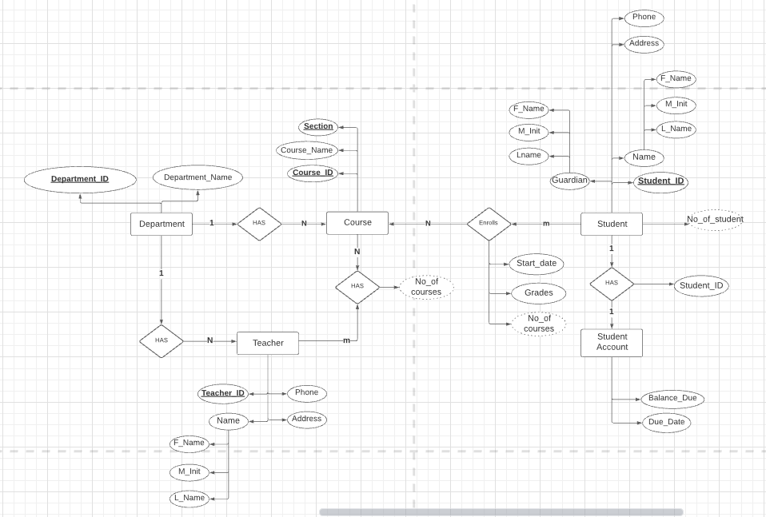s